SCHOOL OF COMPUTER SCIENCE AND ARTIFICIAL INTELLIGENCE |  |  |  |  | DEPARTMENT OF COMPUTER SCIENCE ENGINEERING
Program Name: B. Tech |  |  |  | Assignment Type: Lab |  |  | Academic Year:2025-2026
Course Coordinator Name |  |  |  | Dr. Rishabh Mittal
Instructor(s) Name |  |  |  | Mr. S Naresh Kumar  Ms. B. Swathi  Dr. Sasanko Shekhar Gantayat  Mr. Md Sallauddin  Dr. Mathivanan  Mr. Y Srikanth  Ms. N Shilpa  Dr. Rishabh Mittal (Coordinator)  Dr. R. Prashant Kumar  Mr. Ankushavali MD  Mr. B Viswanath  Ms. Sujitha Reddy  Ms. A. Anitha  Ms. M.Madhuri  Ms. Katherashala Swetha  Ms. Velpula sumalatha  Mr. Bingi Raju
Course Code |  |  | 23CS002PC304 | Course Title |  | AI Assisted Coding
Year/Sem |  |  | III/II | Regulation |  | R23
Date and Day  of Assignment |  |  | Week4 – Wednesday | Time(s) |  | 23CSBTB01 To 23CSBTB52
Duration |  |  | 2 Hours | Applicable to  Batches |  | All batches
AssignmentNumber:7.3(Present assignment number)/24(Total number of assignments)
 | Q.No. | Question |  |  |  |  |  | Expected Time  to complete
 | 1 | Lab 7: Error Debugging with AI: Systematic approaches to finding and fixing bugs  Lab Objectives  • To identify and correct syntax, logic, and runtime errors in Python programs using AI tools  • To understand common programming bugs and AI-assisted debugging suggestions  • To evaluate how AI explains, detects, and fixes different types of coding errors  • To build confidence in using AI for structured debugging practices  Lab Outcomes (LOs)  After completing this lab, students will be able to:  • Use AI tools to detect and correct syntax, logic, and runtime errors  • Interpret AI-suggested bug fixes and explanations  • Apply systematic debugging strategies using AI-generated insights  • Refactor buggy code using reliable programming patterns  Task 1: Fixing Syntax Errors  Scenario  You are reviewing a Python program where a basic function definition contains a syntax error.  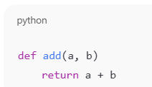  Requirements  • Provide a Python function add(a, b) with a missing colon  • Use an AI tool to detect the syntax error  • Allow AI to correct the function definition  • Observe how AI explains the syntax issue  Expected Output  • Corrected function with proper syntax  • Syntax error resolved successfully  • AI-generated explanation of the fix  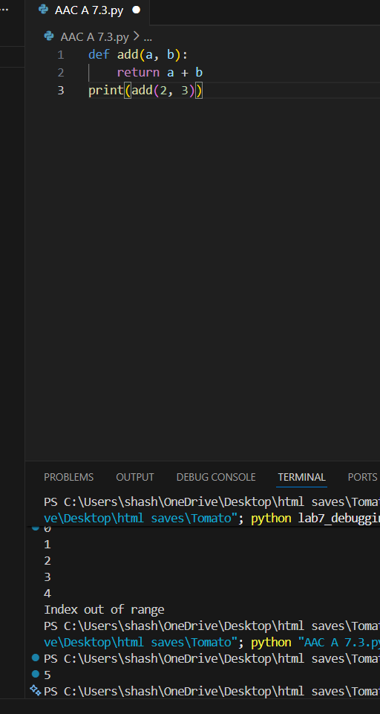  Task 2: Debugging Logic Errors in Loops  Scenario  You are debugging a loop that runs infinitely due to a logical mistake.  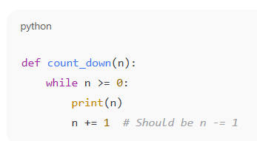  Requirements  • Provide a loop with an increment or decrement error  • Use AI to identify the cause of infinite iteration  • Let AI fix the loop logic  • Analyze the corrected loop behavior  Expected Output  • Infinite loop issue resolved  • Correct increment/decrement logic applied  • AI explanation of the logic error  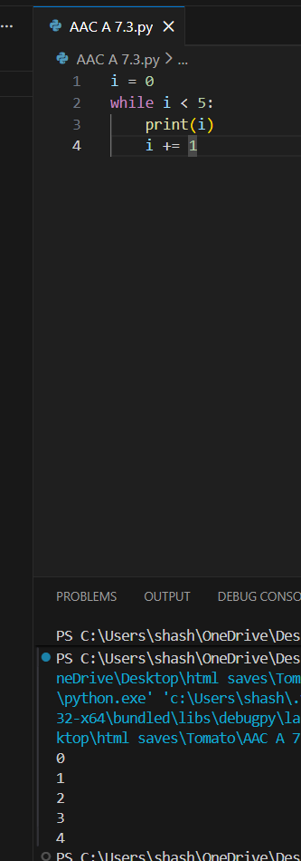  Task 3: Handling Runtime Errors (Division by Zero)  Scenario  A Python function crashes during execution due to a division by zero error.  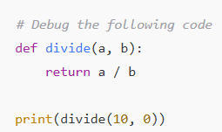  Requirements  • Provide a function that performs division without validation  • Use AI to identify the runtime error  • Let AI add try-except blocks for safe execution  • Review AI’s error-handling approach  Expected Output  • Function executes safely without crashing  • Division by zero handled using try-except  • Clear AI-generated explanation of runtime error handling  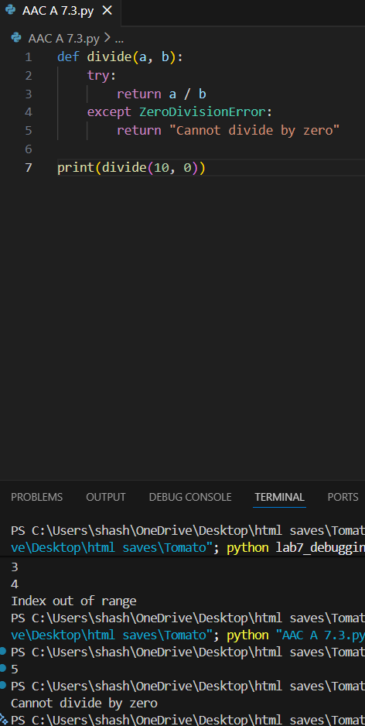  Task 4: Debugging Class Definition Errors  Scenario  You are given a faulty Python class where the constructor is incorrectly defined.  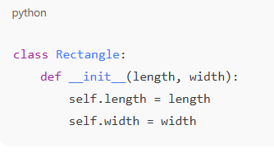  Requirements  • Provide a class definition with missing self-parameter  • Use AI to identify the issue in the __init__() method  • Allow AI to correct the class definition  • Understand why self is required  Expected Output  • Corrected __init__() method  • Proper use of self in class definition  • AI explanation of object-oriented error  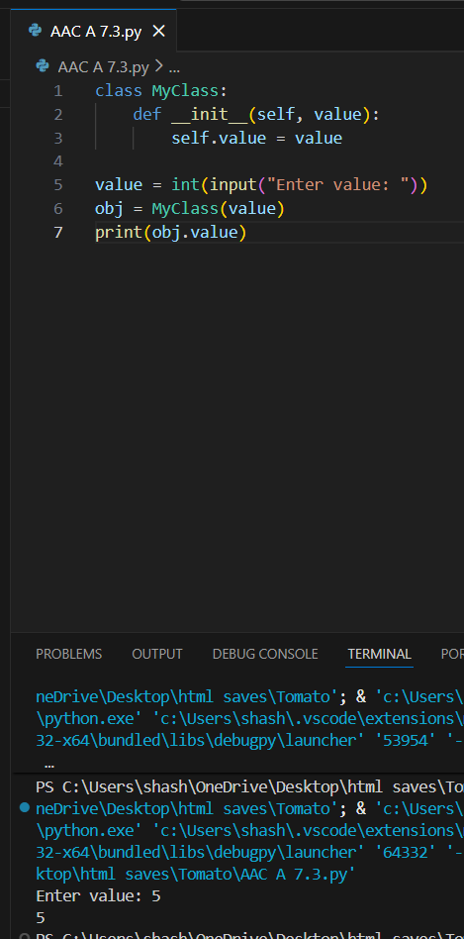  Task 5: Resolving Index Errors in Lists  Scenario  A program crashes when accessing an invalid index in a list.  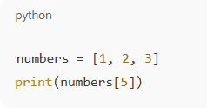  Requirements  • Provide code that accesses an out-of-range list index  • Use AI to identify the Index Error  • Let AI suggest safe access methods  • Apply bounds checking or exception handling  Expected Output  • Index error resolved  • Safe list access logic implemented  • AI suggestion using length checks or exception handling  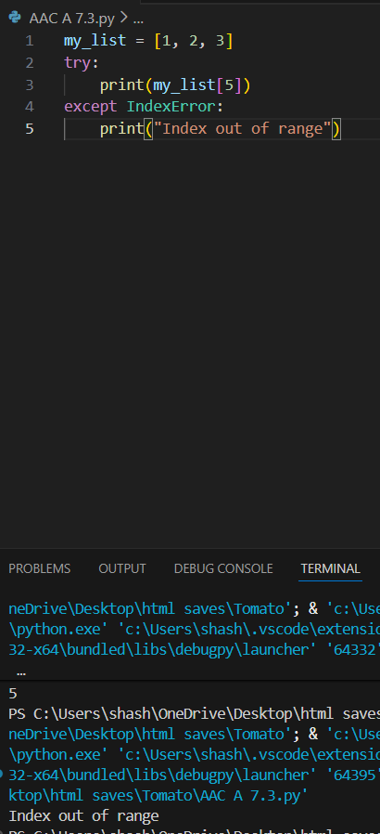  Note: Report should be submitted a word document for all tasks in a single document with prompts, comments & code explanation, and output and if required, screenshots |  |  |  |  |  | Week4 - Wednesday

